template for preparing final manuscripts for publication in the NZSEE bulletin

Bulletin Editor1 and Rajesh P. Dhakal2

(Submitted *September 2025*; Reviewed *October 2025*; Accepted *November 2025*)

# abstract

This document provides the template for preparing the final manuscript (both *articles* and *technical notes*) that have been accepted for publication in the Bulletin of the New Zealand Society for Earthquake Engineering.

An abstract is mandatory for all articles/notes. The abstract should succinctly summarise the objectives and conclusions of the paper in about 250 words. Authors using this document as a template should simply copy the actual abstract paragraphs and paste (in *Keep text only* mode) here replacing these two explanatory paragraphs.

1 Blank Line

**Introduction**

This document describes guidelines for preparing the layout of an *article* or a *technical note* that has been reviewed, revised and accepted for publication in the Bulletin of the New Zealand Society for Earthquake Engineering. Note that this format is required only for the final manuscript after the paper has been accepted for publication following the review process as per the journal policy.

*Articles* or *technical notes* for first review or a subsequent re-review (where requested by the reviewer/s) can be prepared and submitted in single column double spacing format. Once accepted, all final manuscripts must conform to these formatting guidelines.

# Sections, headers and footers

The title, authors’ names, paper processing milestone dates and the abstract are included in the first section of the document (i.e. Section 1), which is in a single column format. The next section (i.e. Section 2) starts below the abstract, and is in two-column format. Tables and figures can either span one or two columns depending on their width. If necessary, additional sections can be created to accommodate figures and tables that span two columns. Note full page figures and tables can also be accommodated without creating additional sections (as explained later).

Authors’ affiliation must be provided in the footer of the first page. For all co-authors, the affiliation shall include his/her position title, employer’s name, location (city only), email address (mandatory for the corresponding author; optional for other co-authors), and NZSEE membership status (if applicable). For papers with less/more than two authors, delete the existing lines or enter extra lines as necessary.

The corresponding author should be identified with a “*Corresponding Author*” before the author’s affiliation. For example; the second author is identified as the corresponding author for this template. The corresponding author should enter the submission, review, and acceptance dates (month and year). The review date refers to when the first round of review was communicated to the authors; and the accepted date corresponds to when the formatted paper was accepted for publication; so there can be a long gap between these two dates (especially if the paper had to go through more than one round of review). The dates entered by the authors will be checked by the Editor and may be amended if found different from those in the Editor’s record.

The authors need not make any changes to the headers in this document. The Editor will enter the volume and the issue numbers in the header of the first page the correct page numbers at the top of all pages.

# text

## Page Setup

If this template is not used, the document needs to be setup to result in a similar page layout. For the first page, both the top and bottom margins are 3cm; whereas for all other pages the top and bottom margins are 2cm and 1.5cm, respectively. The side (i.e. left and right) margins are 2cm for all pages. The header and footer are setup to start 1cm from the edges. Page numbers are to be set differently for the odd and even pages. For clarity, authors should check the page and header/footer setups in different pages of this template.

## Main Body

Font (type, size and emphasis) and paragraph (alignment, spacing etc) for different parts of a typical manuscript (normal text, different level headings, figure/table captions etc) have been standardised in the *Styles* menu of this document. Authors can easily assign the desired format to any text using the Style menu.

For example, a *Normal* paragraph may be converted to a heading by simultaneously pressing the ALT key, the SHIFT key and either the left or the right cursor key (i.e., ← or →). Use the left cursor key for a heading style with the same level as the previous one and the right cursor key for a heading style with the next greater level. Press the same cursor key again to further reduce or increase the level.

Except for the Title and Authors’ names (which are in 14 points Times New Roman font), all other parts should be typed in 9 points Times New Roman font. The main body of the manuscript is typed single spaced and prepared in the *Normal* style (available in the *Styles* Menu) which has a 6 points gap between paragraphs. Provide only a single space after a full stop when starting a new sentence.

1. Use this *numbered* format for numbered lists.
2. Copy this line elsewhere in the document but you may need to check that the numbering starts correctly both here and in the new location.

* Bulleted lists may also be used (not normally immediately after numbered lists though). The numbers/bullets should be aligned in line with the margin.
  + Where second level bullets/numbers are needed, they should be aligned with the text of the first level bullets/numbers.

## Headings

All headings start after a 12 points gap from the previous text/heading. The styles required for different levels of headings are shown in Figure 1. Authors should try not to use the third and fourth level headings, where possible.

Figure 1: Styles for different levels of heading.

# First Level Headings

## Second Level Headings

### Third Level Headings

#### Fourth level headings:

## References

Citations to references should be made using numbers in square brackets within the text [1]. The bracketed numbers can be provided either inside a sentence (generally immediately following the reference details used as the subject) or at the end of a sentence. Some examples follow: (i) Vertical motions recorded in some earthquakes have been found to have peak accelerations in excess of 2g [2]. (ii) Jeffery and Peters [3] have conducted real time pseudo-dynamic tests on several RC bridge piers. (iii) According to the NZ Concrete Standard [4], buckling of bars can be avoided if stirrups are spaced closer than six times the diameter of longitudinal bars. (iv) Several modelling techniques [5-8] have been reported in literature.

Citations should be numbered in the order they appear in the text. Where two references are cited together, separate them by a comma [9,10]. If three or more references are to be cited, a hyphen can be used to indicate a range of continuously numbered references [2,11-14]. Different formatting styles are used for listing different types of cited references; these are explained at the end of this template.

## Figure and Table Captions

Captions for figures and Tables should use the *Figure Caption* and *Table Caption* styles, respectively. Table captions should be provided above a table, whereas figure captions are provided below a figure. Both are centrally aligned in ***bold italics*** 9 points Times New Roman font. The captions should start with *Table* or *Figure*, followed by the *number:* and the figure/table title, and end with a full stop; e.g. ***Figure 1: Test setup.*** or ***Table 1: Geometrical properties of the specimens.***

A 12 points gap should be provided before the Table caption and the preceding text, and a 6 points gap between the caption and the Table. Similarly, a 6 points gap is provided between a figure and its caption and a 12 points gap between a figure caption and the following text/heading. If required, a footnote should be typed under a Table in size 8 font with respectively 3 and 12 points spacing above and below it.

# graphics

Figures need to be provided close to the text introducing them. They could either occupy a column or cover the full width of the page. Photographs and relatively simple line-art diagrams may usually be placed within a single column. However, it may be easier to control the layout of the paper by grouping a number of smaller figures (wherever feasible) to create a combined figure occupying the width of a column or full page Where appropriate, the figures should be placed at the top or bottom of a page.

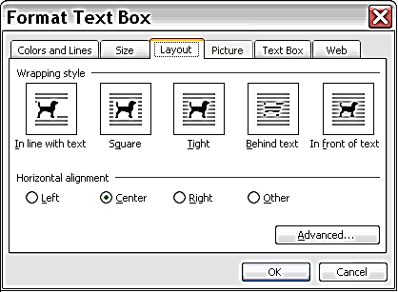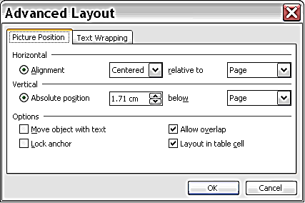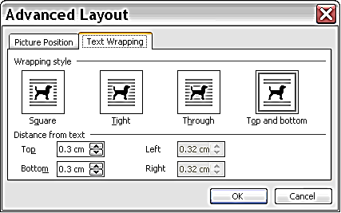

Figure 2: Screen clips from Microsoft Word for the full width text box used for Figure 3.

Placing figures (especially, those which are wider than a single column) in the text can be challenging and frustrating. There are several methods of placing them. The most flexible method is to include the figures in a table (or text box) that is positioned relative to the page because this allows the text to flow or reposition itself around the figure automatically. The layout settings for a text box are shown in Figure 2. The lower two dialog box pages are displayed using the *Advanced* button on the top dialog box.

The same layout can be created using section breaks, with the sections alternating between single and two columns, but the text needs to be repositioned manually. For example, a section break is created here to fit Figure 3.

Single column figures (like Figure 1 and Figure 2) should use the ‘In line with text’ format (top left of Figure 2) so they move with the text and stay above of their caption. The figures are centred like a normal paragraph. Tables may be used to place one or more parts of the figure side-by-side.

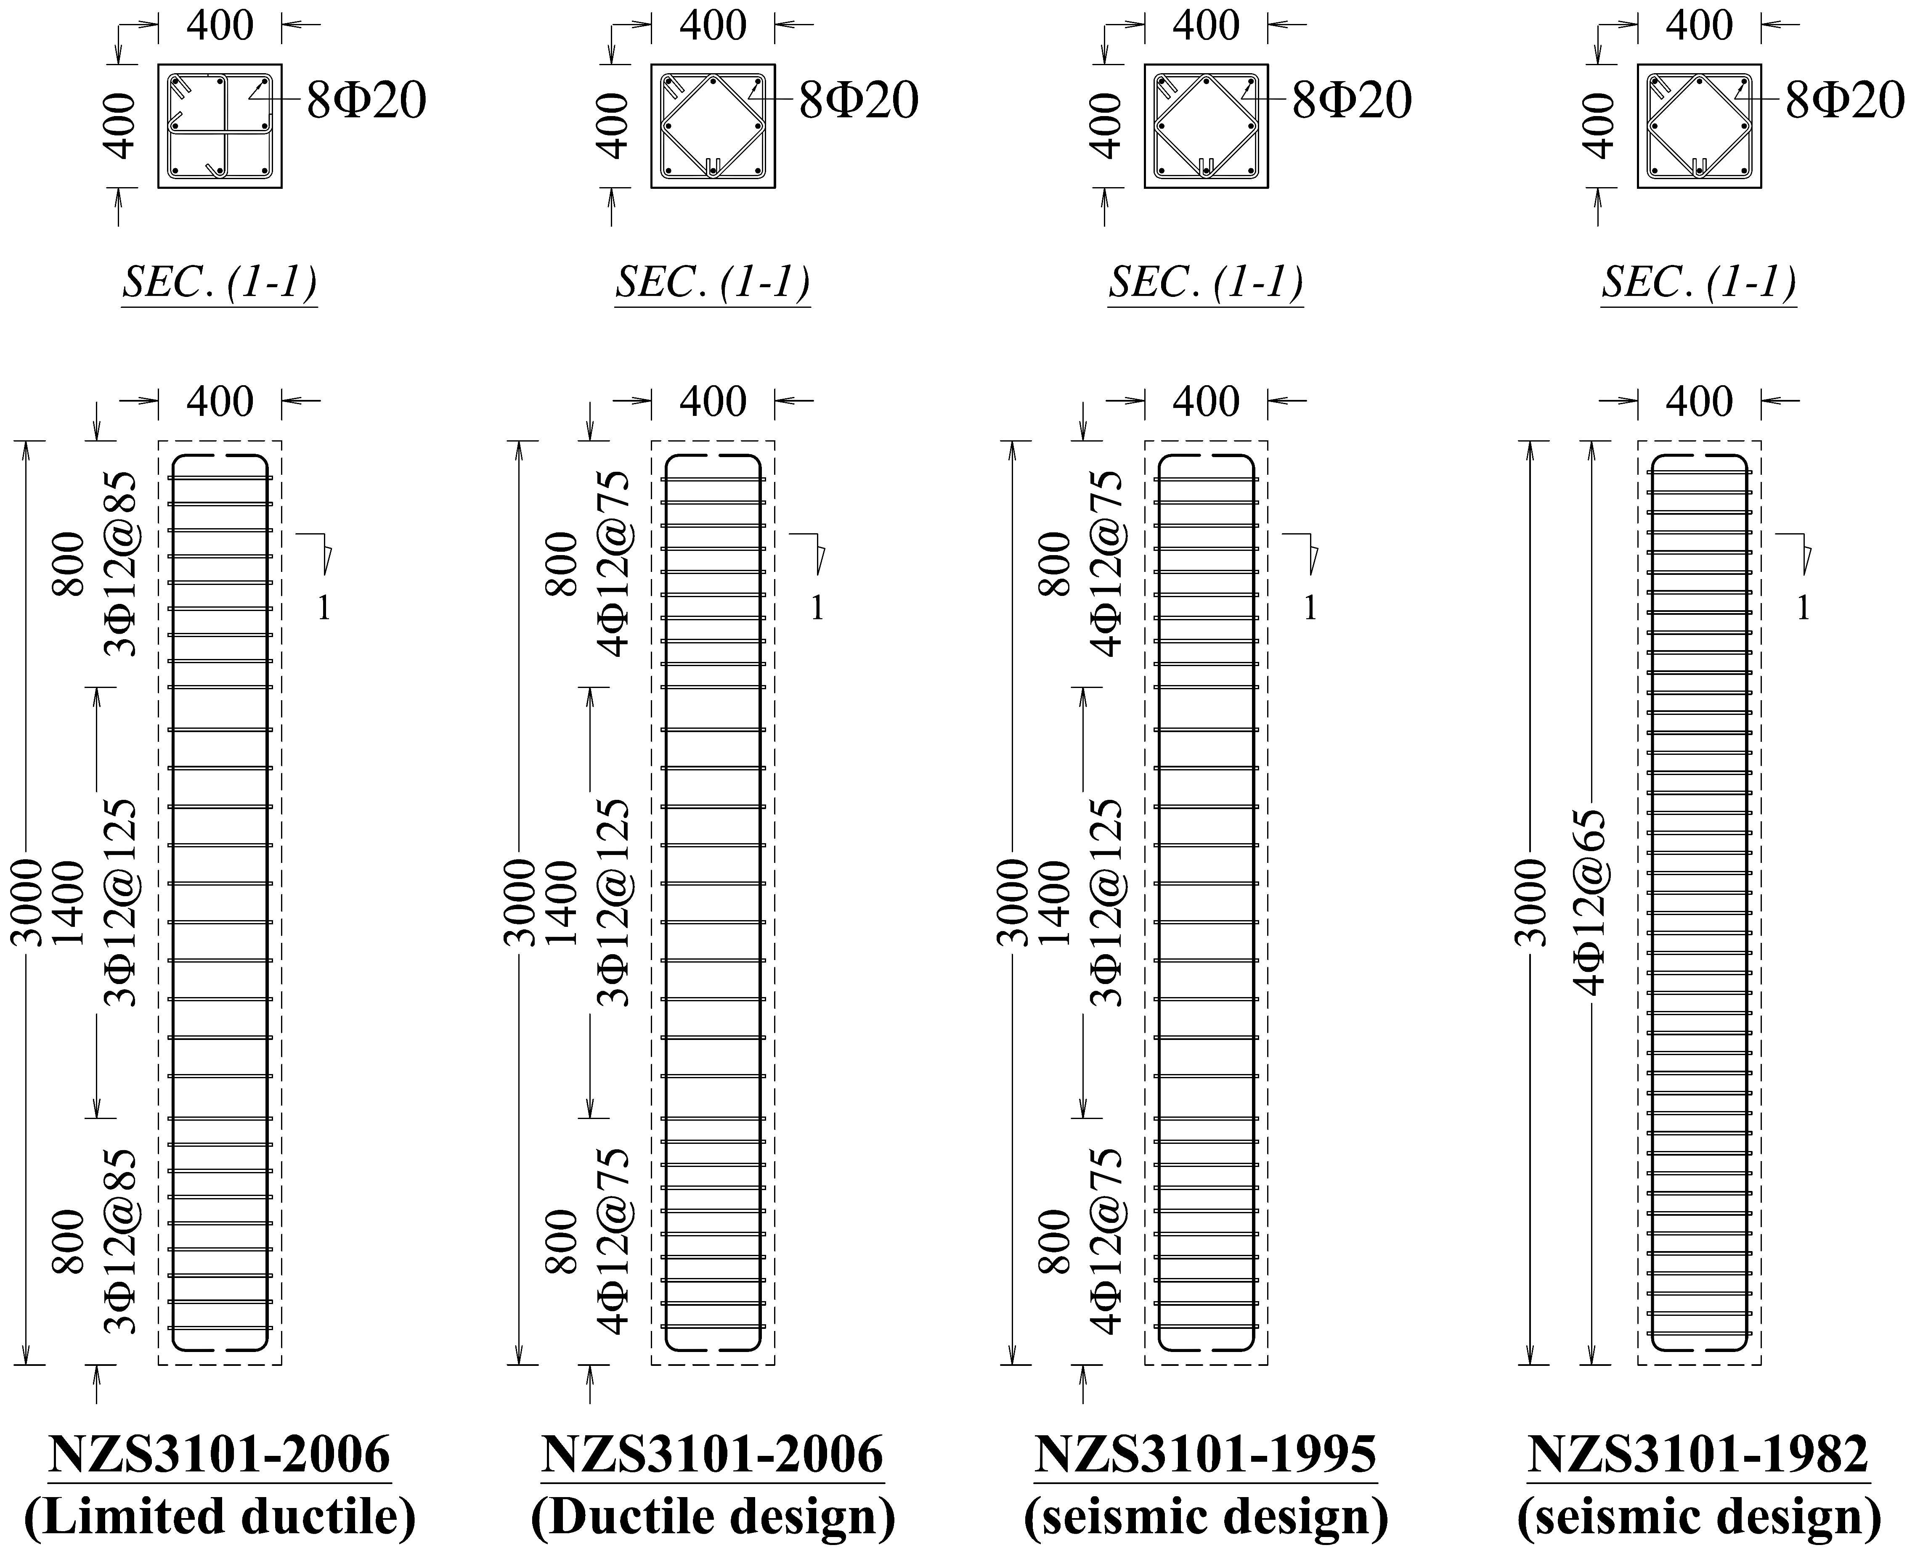

***Figure 3: Typical reinforcement details in columns designed using seismic requirements of different versions of NZS3101.***

## Colour

If you choose to use coloured graphics, ensure that they are still clear when printed on a black and white printer. The on-line (pdf) version of the paper will contain the coloured graphics. Sections of the paper can be printed in colour by negotiation with the Editor. There is usually a cost for this, so judicious layout can utilise colour on all 4 pages (2 leaves) required by the printing process.

## Line Art

Paste line art from other software into the document as a picture (i.e., select ‘Picture’ from the Insert ->Paste Special Paste menu in Word) rather than as an editable object. The diagram can be pasted straight into the document, but this increases the size of the document file.

Keep line art figures as simple as possible. The labels in the figures should be easily readable; font size should not be smaller than 8 points. Lines should preferably be at least 0.2 mm thick. Make the lettering size and line thickness proportionally larger if the diagram size is to be reduced after it is inserted into the paper. Figures should not be wider than 170 mm. Avoid excessive notes and designations.

Black line-art is the best. Lighter coloured lines may be printed with jagged edges. Avoid shaded regions, which may not print uniformly, and avoid very light colours, like yellow, which are almost indistinguishable in a white background.

When a figure and its annotations and arrows are in separate text boxes, these should be grouped. Otherwise, when the main figure is moved the annotations and arrows get left behind. Avoid putting figures (graphs) which draw their data from other files (imbedded) as these are very challenging to manipulate (unavoidable during final editing) in the Bulletin setting. Such figures should be pasted as pictures.

## Scanned Items

### Photos

Photos should be scanned so they have a resolution of 200 dpi (e.g. scan them at 400 dpi if you intend to enlarge them to double their original size or 100 dpi if you will reduce them to half their original size). Their black (saturation) level should be at least 95%, which gives them a slightly grey appearance when viewed on the screen. They need to be saved either in a TIFF or an EPS format.

### Line Art

If diagrams really need to be scanned, please scan them at a resolution of 600 dpi and have the software save them in a TIFF, GIF or PNG format. The JPG format is only for photographs. It reduces the quality of line art by smearing lines as it compresses the image.

## Digital Photographs

The requirements for these are similar to those for scanned photos. Don't convert digital photos to TIFF or EPS format though, leave them in their original format (probably JPG or JPEG) to avoid reducing the image quality.

## Reducing the Document Size

You may be able to reduce the size of the finished document by compressing and cropping scanned images. The dialog box used to do this is displayed using the ‘compress’ button on the ‘Picture’ tab of the Format Picture dialog box. Save a copy of the document before doing this in case the quality is reduced by this process or you need to enlarge the graphics.

# Equations

For equations within a paragraph with no subscripts or superscripts, such as sinθ = (*x* + *y*) *z*, use italic letters for variable names to replicate the format used in the Equation Editor.

For other equations, create the equation using the Equation Editor. Do not paste equations as objects/pictures as there cannot be edited. Follow the equation with a tab and a sequential equation number between parentheses. See for example, Equation 1 below:

 (1)

where *ca* = interface adhesion;   
δ = friction angle at interface; and   
*k*1 = shear stiffness number.

[Microsoft Word sometimes refuses to save a document containing equations, with a misleading message that the disk is full. If this happens (usually after an auto-save while you are editing an equation), select every equation in the document and delete the ones that don’t display the message “Double click to edit Microsoft Equation editor 3.0” in the bottom status bar. Try saving the document after you delete each of the equations that have been converted into ordinary pictures.]

# Tables

Locate tables close to the first reference to them in the text and number them consecutively. Place the caption above the table to the same width as the table (*Table caption* style). Start all major words of the headings with a capital letter and align the headings to the column left or centre so that they are consistent with the entries in the column. Indicate units in a line below the heading. Explanations should be given at the foot of the table. Use the *Table text* style for the remaining text. If notes are required, use the following reference marks: *, **, etc. and place the footnotes directly underneath the table. Use lines sparingly to separate groups of cells from others. See for example, Table 1.

Table 1: Summary of the significant test properties.

|  |  |  |  |
| --- | --- | --- | --- |
| Specimen* | Ultimate Strength (kN) | Initial Stiffness (kN/mm) | Earthquake Record |
| Interior | 27 | 5.7 | 1.25 × El-Centro 1940 |
| Exterior | 14 | 3.0 | NZS 4203 Matahina |

*Labelled according to its position in the building.

# final notes

Please follow the guidelines as closely as possible to ensure your paper isn’t held up because it does not have the correct format. For convenience, the major formatting features are listed in Table 2.

Avoid changing margins, styles and fonts, particularly when pasting material from other documents. If you need to do this, it is often better to paste “unformatted text” from the Insert ->Paste Special menu.

# Acknowledgments

To be provided (as appropriate) only if needed. An example is provided below.

The authors are thankful to Mr Les Megget and Dr Liam Wotherspoon from University of Auckland; and Dr Bruce Deam from Knowledge Exchange Ltd. for reviewing this template.

# CITATIONS

References should be cited in the manuscript with numbers in sequence; e.g. the first cited reference shall be numbered [1], and the numbers should sequentially increase in the order of their appearance in the text. All references cited in the text must be listed in the reference, and all references listed must be cited in the text. The listed references must also be numbered and sequenced as cited in the text (i.e. NOT alphabetically).

Names of all co-authors must be written for all references (i.e. writing just the first author’s name followed by *et. al.* is not allowed). An author’s name should be written as (surname followed by initials of the first and middle names; e.g., Smith JB). The first letter of all words should be capital when writing the names of a journal/conference. Formatting details of different types of reference are summarized below.

## Journal Articles (For example, see References 1-3)

Surname1 Initials1, Surname2 Initials2 and Surname3 Initials3 (Year). “Title of journal article”. *Journal Name* *in Italics with the First Letter of all Main Words Capital*, **Vol**(Issue): page start-page finish. [https://doi.org/doi number](https://doi.org/doi%20number) (online link if the journal is not doi registered)

## Conference Papers (For example, see References 4-5)

Surname1 Initials1, Surname2 Initials2 and Surname3 Initials3 (Year). “Title of conference paper”. *Conference Name* *in Italics* *with the First Letter of all Main Words Capital*, Date, City, Vol.# (if applicable), Paper ID or page numbers. online link where available

## Personal Reports (For example, see Reference 6)

Surname1 Initials1, Surname2 Initials2 and Surname3 Initials3 (Year). “*Title of Report* *in Italics* *with the First Letter of all Main Words Capital*”. Report ID, Publishers’ Employer, City, Number of pages. online link where available

## Institutional Reports/Standards (For example, see References 7-8)

Publishing Institution (Year). “*Title of Report/Standard in Italics with the First Letter of all Main Words Capital*”. Report/Standard ID, Reporting Institute, City, Number of pages. online link where available

## Theses (For example, see References 9-10)

Surname Initials (Year). “*Title of the Thesis in Italics with the First Letter of all Main Words Capital*”. Masters Thesis OR PhD Dissertation, University Name, City, Country, Number of pages. online link where available

## Books (For example, see Reference 11)

Surname1 Initials1, Surname2 Initials2 and Surname3 Initials3 (Year). *Title of the Book in Italics with the First Letter of all Main Words Capital*. Edition (if applicable), ISBN Number where available, Publisher, City/Country, Number of pages. online link where available

## Book Chapters (For example, see Reference 12)

Surname1 Initials1, Surname2 Initials2 and Surname3 Initials3 (Year). “*Title of the chapter in italics*” Page start-finish in *Title of the Book* *in Italics with the First Letter of all Main Words Capital*. Editors: Name, ISBN Number where available, Publisher, City/Country. online link where available

## Online Information (For example, see References 13-14)

Publisher. *Title of information* *in italics*. Website address (accessed date)

## Newspaper/Media Article (For example, see Reference 15)

Reporter’s Full Name. *Title of the article* *in italics*. Media/Newspaper Name, Published date. Online link

# references

1. Carradine DN, Kumar A, Fairclough R and Beattie G (2020). “Serviceability fragility functions for New Zealand residential windows”. *Bulletin of the New Zealand Society for Earthquake Engineering*, **53**(3): 137-143. <https://doi.org/10.5459/bnzsee.53.3.137-143>
2. Pourali A, Dhakal RP, MacRae G and Tasligedik S (2017). “Fully-floating suspended ceiling system: Experimental evaluation of structural feasibility and challenges”. *Earthquake Spectra*, **33**(4): 1627-1654. <https://doi.org/10.1193/092916EQS163M>
3. Mulligan J, Sullivan TJ and Dhakal RP (2020). “Experimental seismic performance of partly-sliding partition walls”. *Journal of Earthquake Engineering*. (Accepted for publication, published online) <https://doi.org/10.1080/13632469.2020.1733139>
4. Stanway J, Sullivan T and Dhakal RP (2018). “Towards a new delivery approach to improve the performance of non-structural elements in New Zealand”. *17th US-Japan-New Zealand Workshop on the Improvement of Structural Engineering and Resilience*, November 12-14, Queenstown, New Zealand, 8pp. <https://atcouncil.org/docman/atc-15-16-papers/174-p2-10-stanway/file>

Bradley B, Dhakal RP and Mander JB (2007). “Probable loss model and spatial distribution of damage for probabilistic financial risk assessment of structures”. *10th International Conference on Applications of Probability and Statistics in Civil Engineering* *(ICAPS10)*, July 31-3 August, Tokyo, Japan, Paper No 43, 3 pp.

MacRae GA, Pampanin S, Dhakal RP and Palermo A (2012). “*Review of Design and Installation Practices of Non-Structural Elements*”. Report for the Engineering Advisory Group, Department of Building and Housing, Wellington, NZ, 82pp. <http://www.naturalhazards.org.nz/NHRP/Publications/Research-Publications/Short-Term-Recovery-Programme>

Standards New Zealand (2004). "*NZS1170.5: Structural Design Actions. Part 5: Earthquake Actions ‐ New Zealand*”. Standards New Zealand, Wellington, NZ, 76pp. <https://www.standards.govt.nz/sponsored-standards/building-standards/NZS1170-5>

1. MBIE, NZSEE, SESOC, EQC and NZGS (2017). “*The Seismic Assessment of Existing Buildings – Technical Guidelines for Engineering Assessments*”. Ministry of Business Innovation and Employment (MBIE), New Zealand Society for Earthquake Engineering (NZSEE), Structural Engineering Society (SESOC), Earthquake Commission (EQC), New Zealand Geotechnical Society (NZGS), Wellington, NZ. <http://www.eq-assess.org.nz>

Wilford D (2020). “*Behaviour of Reinforcing Bars under High Speed Strain Reversals*”. Master Thesis, Department of Civil and Environmental Engineering, University of Auckland, Auckland, NZ, 123pp.

Dashti F (2017). “*Out-of-plane Instability of Rectangular Reinforced Concrete Walls under In-plane Loading*”. PhD Dissertation, Department of Civil and Natural Resources Engineering, University of Canterbury, Christchurch, NZ, 323pp. <http://hdl.handle.net/10092/13612>

Dhakal RP, Fenwick RC and Walker A (2008). *Curvature Ductility of Reinforced Concrete Plastic Hinges*. ISBN 978-3-639-04184-2, VDM Publishers, Germany, 155pp.

Dhakal RP and Maekawa K (2001). “*Post-peak cyclic behaviour and ductility of reinforced concrete columns*” Page 193-216 in *Modelling of Inelastic Behaviour of RC Structures under Seismic Loads*. Editors: Shing PB and Tanabe T, ISBN: 9780784405536, American Society of Civil Engineers (ASCE), USA.

GNS Science. *GeoNet*. <http://www.geonet.org.nz> (Accessed 21 September 2014)

MunichRe. *Ten costliest earthquakes ordered by insured losses*. <https://www.munichre.com/site/wrap/get/documents_E2066418540/mr/assetpool.shared/Documents/5_Touch/_NatCatService/Significant-Natural-Catastrophes/2014/10-costliest-earthquakes-ordered-by-insured-losses.pdf> (Accessed 21 January 2018)

Michael Wright. *Christchurch earthquake insurance wrangles endure, six years on*. Press, 25 February 2017. <https://www.stuff.co.nz/business/money/89610941/Christchurch-earthquake-insurance-wrangles-endure-six-years-on>

|  |  |  |  |  |  |
| --- | --- | --- | --- | --- | --- |
| Table 2: Summary of formatting guidelines. | | | | | |
|  | **Font Size1** | **Emphasis** | **Capital/Small** | **Alignment** | **Spacing Before and After** |
| Title | 14 | **BOLD** | **Capital** | **CENTRE OF PAGE** | 6, 18 |
| Authors | 14 | **Bold** | **First Letter Capital** | **Centre of Page** | 12, 12 |
| Submitted, Reviewed and Accepted dates | 9 | Partially *italics* | All Words Start with Capital | Centre of Page | 12, 12 |
| Abstract | 9 | None | Normal | Align left and right (single column) | 6, 6 (1 blank line at the end) |
| Affiliation (1st page footer) | 8 | *Italics* | *All Words Start with Capital* | 1. *Align superscripted numbers to the left (indent text)* | 0, 0 |
| First heading (Introduction) | 9 | **BOLD** | **Capital** | **CENTRE OF COLUMN** | 6, 6 |
| Other Main headings2 | 9 | **BOLD** | **CAPITAL** | **CENTRE OF COLUMN** | 12, 6 |
| Sub-headings | 9 | **Bold** | **All Words Start with Capital** | **Align to the Left** | 12, 6 |
| 3rd level headings | 9 | *Italics* | *All Words Start with Capital* | *Align to the Left* | 12, 6 |
| 4th level headings | 9 | None | Normal | Align to the left | 12, 6 |
| Main text (including Figures and Tables) | 9 | None | Normal | Align left and right (double column) | 6, 6 |
| Figure Captions | 9 | ***Bold Italics*** | ***Normal*** | ***Centre of figure width*** | 6, 12 |
| Table Captions | 9 | ***Bold Italics*** | ***Normal*** | ***Centre of the Table width*** | 12, 6 |
| Text inside Table | 8/9 | As required | As required | As required | 3, 3 |
| Table Footnote | 8 | *Italics* | *Normal* | *Centre of the Table width* | 3, 3 (12 after the last line of the footnote) |
| Numbered/Bulleted lists in the text | 9 | None | Normal | * Align numbers/bullets to the left (indent text) | 3, 3 |
| References | 9 | Partially *italics* | Normal | 1. Align numbers to the left (indent text) | 3, 3 |
| 1All texts in the paper should be written using Times New Roman font.  2Also applies to ABSTRACT, ACKNOWLDEGEMENT, References and Appendix. | | | | | |